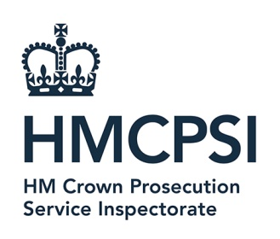 | HM Crown Prosecution Service Inspectorate  7th Floor, Tower  102 Petty France  London  SW1H 9GL  WC2B 4TS  http://www.justiceinspectorates.gov.uk/hmcpsi/

9th February 2024

FOI Request

Thank you for your Freedom of Information dated 6th February. In your request you asked for the following information.
What is the total cost for all translation and interpretation activities for each of the financial years 21/22 and 22/23. I would like a separate total for each financial year.

I can confirm that we do hold information in the scope of this request.

HMCPSI has a nil spend on translation and interpretation costs for the financial years 2021-2 and 2023-3.

If you are dissatisfied with any aspect of our response to your request, please send full details within two calendar months of the date of this email and send to the below email address: info@HMCPSI.gov.uk

You also have the right to ask the Information Commissioner to investigate any aspect of your complaint. Please note that the Information Commissioner’s Office (ICO) is likely to expect the internal complaints procedures to have been exhausted before beginning an investigation.

Yours sincerely

HM Crown Prosecution Inspectorate

