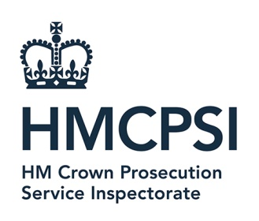 | HM Crown Prosecution Service Inspectorate  7th Floor, Tower  102 Petty France  London  SW1H 9GL  http://www.justiceinspectorates.gov.uk/hmcpsi/

8th May 2024
Dear

FOI Request

Thank you for your Freedom of Information dated 18th April. In your request you asked for the following information.

1.Spend on Office supplies and associated products for the below financial years.
1st April 2022 – 31st March 2023
1st April 2023 – 31st March 2024

2.Start date & duration of Contract?
Is there an extension clause in the contract and, if so, the duration of the extension?
Has a decision been made yet on whether the contract is to be either extended or renewed?

3.Who is the senior officer (outside of procurement) responsible for the contract?
Name of Incumbent Supplier?
How long have you traded with them?

If you publish your register of contracts and purchasing, can you please provide a website link.
In addition, can you confirm if you have a contract in place for Tail End Spend.

For question1, I can confirm that we do hold the information for spend on office supplies as follows:

1st April 2022 – 31st March 2023 = £109.66
1st April 2023 – 31st March 2024 = £40.09

In relation to questions 2 - 3, HMCPSI does not hold the information in scope of this request. HMCPSI is a small government department of under 26 staff and we do not have a contract for office supplies. The provision of stationery is included in the rental costs of our offices.

If you are dissatisfied with any aspect of our response to your request, please send full details within two calendar months of the date of this email and send to the below email address: info@HMCPSI.gov.uk

You also have the right to ask the Information Commissioner to investigate any aspect of your complaint. Please note that the Information Commissioner’s Office (ICO) is likely to expect the internal complaints procedures to have been exhausted before beginning an investigation.

Yours sincerely

HM Crown Prosecution Inspectorate

